**HTML Tutorial W3**

**HTML Introduction:**

**What is HTML?**

HTML stands for Hyper Text Markup Language.

HTML is the standard markup language for creating Web pages.

HTML describes the structure and layout of a Web page.

With HTML you can create your own websites.

**What does HTML consist into?**

HTML consists into 3 main parts:

1. Tags
2. Elements
3. Attributes

Below line will edit and modified in future:

HTML consists of a series of elements.

HTML elements tell the browser how to display the content.

HTML elements label pieces of content such as "this is a heading", "this is a paragraph", "this is a link", etc.

**My Own:**

We can only put the contents in the website using different types of tags in HTML.

**Versions of HTML:**

There are many versions of HTML from "HTML1.0” to “HTML5".

The latest version of HTML is "HTML5.2".

This tutorial follows the latest HTML5 standard.

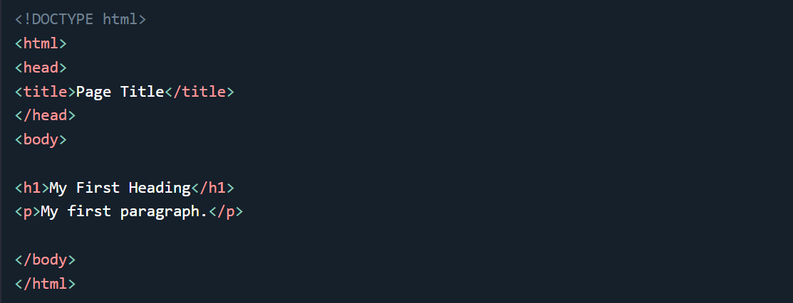**A Simple HTML Document:**

**Explanation:**

* The <!DOCTYPE html> declaration defines that this document is an HTML5 document.
* The <html> element is the root element of an HTML page.
* The <head> element contains meta information about the HTML page.
* The <title> element defines the title for the webpage (which is shown in the browser's title bar or in the page's tab).
* The <body> element defines the document's body, and it is a container for all the visible contents of a webpage, such as headings, paragraphs, images, videos, hyperlinks, tables, lists, forms, etc.
* All the contents that are present under the body tag, display in the browser or website.
* The <h1> element defines a large heading.
* The <p> element defines a paragraph or some text.

**Visualization of HTML Page Structure:**

Below is a visualization of an HTML page structure:

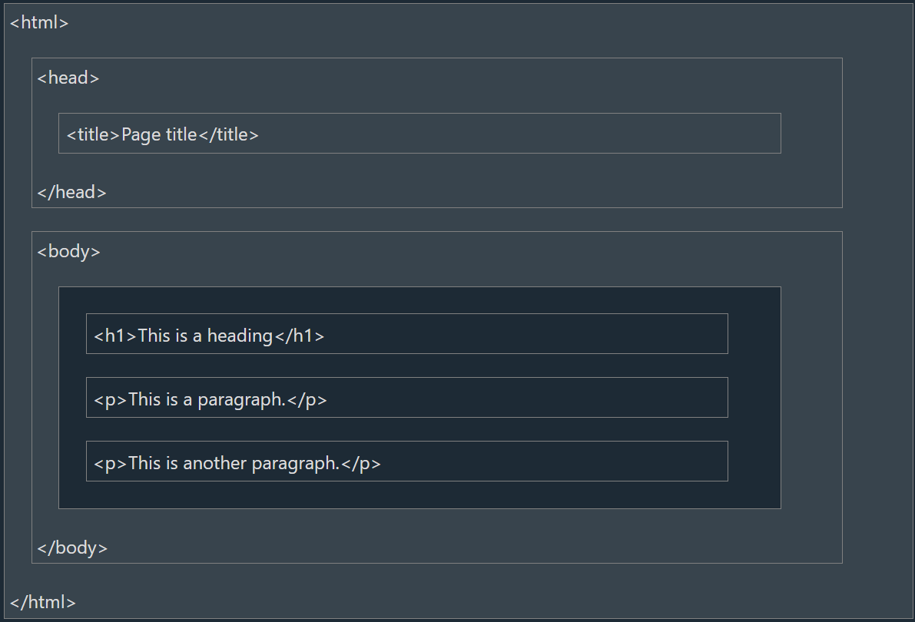

**Note:** The content inside the <body> section will be displayed in the browser or website. The content inside the <title> element will be shown in the browser's title bar or in the page's tab.